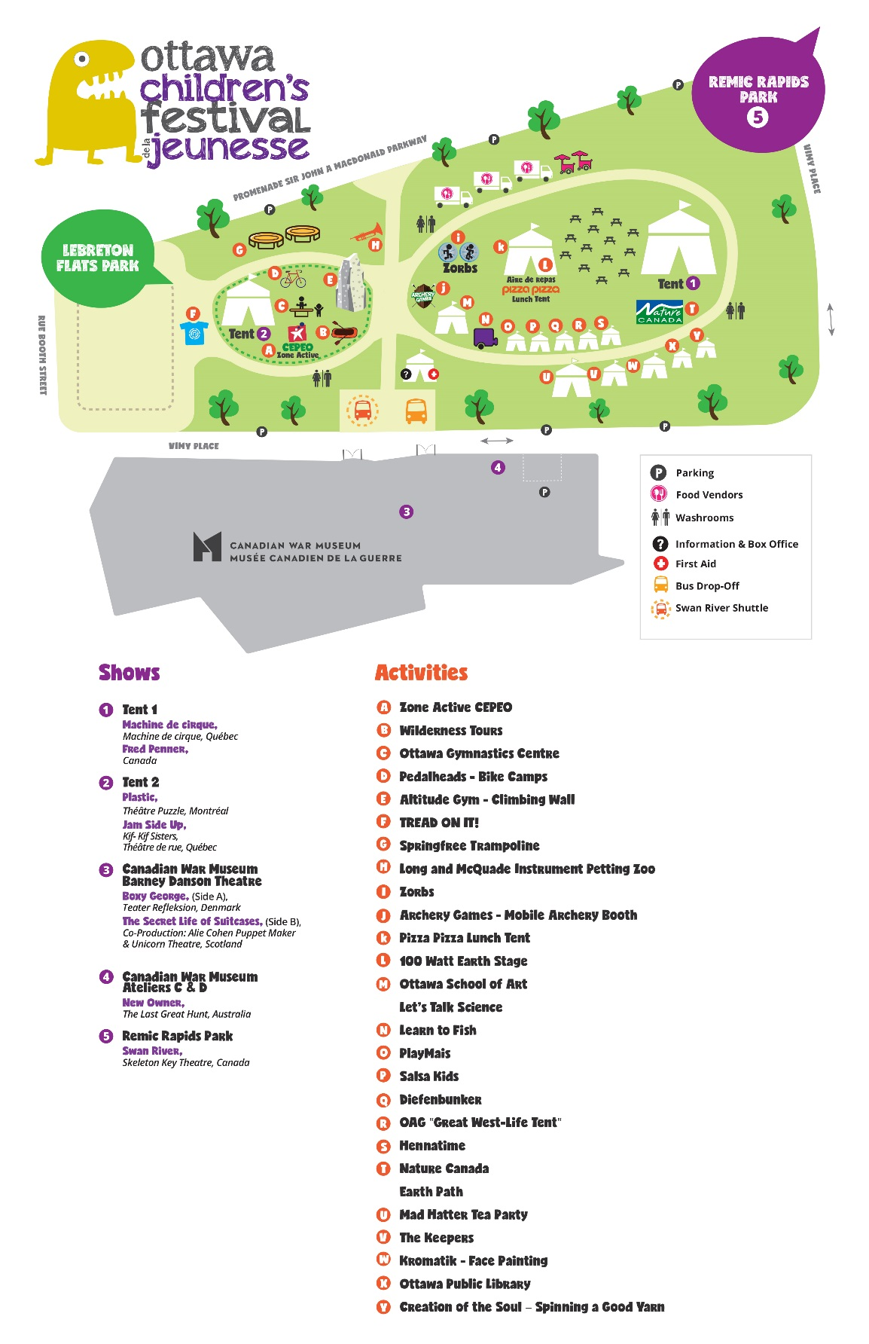 |  | MONSTER Scavenger hunt  School  Student Name  Student Grade  Teacher’s Name  teacher’s Contact Info

Instructions: Read the clues below. Find out which monster is in each location and put the number of that monster in the box beside the clue. Get all 10 right and you could win!
 |  |  |  |  | 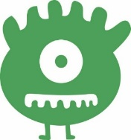
1 | 2 | 3 | 4 | 5 | 6 | 7 | 8 | 9 | 10
Which monster is here?  I’m seeing a show - Bernie got spooked and bolted away. Lost, alone and hungry he makes his way through the city streets. |  |  |  |  | Which monster is here?  Head out into the wild and find who Keeps animals safe.
Which monster is here?  Jump, run and stay Active - find the Zone where  you have to be energetic. |  |  |  |  | Which monster is here?  Play with “Mais” and stick together a monster  craft that you can take home with you.
Which monster is here?  I’m in a different kind of Zoo. No animals here,  just a musical crew. |  |  |  |  | Which monster is here?  I can eat in here AND enjoy an amazing show  put on by kids like you!
Which monster is here?  Latin dances are fun to do, learn the Cha-cha  and the Bachata too. |  |  |  |  | Which monster is here?  It’s Time to get some funky, fun Henna tattoos.
Which monster is here?  Are you thirsty? Grab a chair and join me at a tea party. |  |  |  |  | Which monster is here?  Back where it all began – in the office that  rhymes with fox.

Return completed Scavenger Hunt to the Box Office Tent.

We will select two winners each day. Each winner selected will receive a special prize!
Only completed entries, with correct monsters from each location, will be eligible to win.

